You Are a Star of God

Click or tap to enter a date.   
**Ages 8-10**

**When**Click or tap here to enter a time.

**Where**Click or tap here to enter a location.

**Program Length:** 2 ½ hours

**Program Description**Discover more about who you truly are as Soul. Have fun seeing your life through spiritual eyes.

**Spiritual Purpose and Benefits**

* Youth explore who they are as Soul and Soul’s Godlike qualities.
* Youth experience the joy of being Soul.

**Program Overview**

Pre-Session Volunteer Meeting

Welcome Activity – Stars of God Art Cards

HU Song and Group Meeting

Get to Know Soul – Matching Game

A Look in the Mirror – Spiritual Exercise and Craft

Soul Dreaming– Collaborative Song

Clean Up, Sharing, and Feedback

Pre-Session Volunteer Meeting (45 minutes)

* Introductions and HU Song
* Brief review of volunteer roles
* Safety review
* Program review
* Questions and answers

Supplies

* “Soul Is” sign for each table
* Scratch art cards and sticks
* Paper plates, one for each youth
* Hole punchers
* Paper clips
* Rubber Bands

Welcome Activity– Stars of God Cards (up to 30 minutes)

* Group Leaders welcome youth as they arrive and introduce the spiritual focus of the activity: *Today we are talking about how you are a star of God! We all have these bodies, but that isn’t who we really are. The real you is Soul.*
* Show youth the “Soul Is” sign in the middle of the table. They can read it to learn a little more about themselves as Soul.
* *You can make scratch art cards that show something special about Soul.*
* Show them a few example cards with special qualities of Soul on them (Soul is full of light and love, Soul lives forever, Soul is a happy being).
* 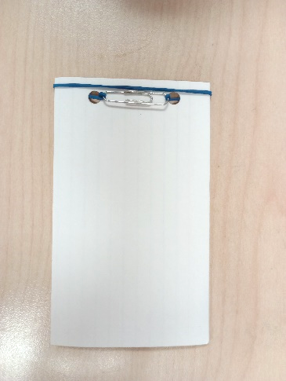Youth use the provided paper plate or a tray to contain the mess/crumbs as they create their scratch art cards.
* As time allows, youth can create a small book of their art cards:
  + Use a hole puncher to put two holes on the left side of each card.
  + Line up all the cards. Lace the rubber band through the holes.
  + Use a paper clip to keep the rubber band in place, as shown in the picture.
* The Room Leader gives a one minute warning before the Group Meeting begins so that youth can clean up their work spaces and go to the trash bin to dispose of the crumbs from the scratch art.

Welcome, HU Song, and Group Meeting (20 minutes)

🗎 Note to Group Leaders: Please sit with youth during the large group HU and Guidelines/Rules.

* Youth and volunteers come together in a large circle.
* The Room Leader welcomes the youth.
* Introduce the session theme: *Today’s program is all about exploring who you truly are as Soul.*
* Explain what the HU is and how it can help us remember that we are Soul and tune into God’s love for us.
* Lead the group in a HU song.

**Icebreaker Activity**

* *Each of us is a unique spark of God. Let’s get to know a little bit about each other!*
* Youth get to know one another by playing a name echo game: Each person takes a turn saying their name and something they like to do, and does a movement inspired by the activity they like to do. For example, “My name is Emma and I like to draw,” followed by acting out drawing something.
* The whole group repeats the person’s name and movement one time. Continue around the circle until everyone has had a turn.

**Ground Rules**

* Room Leader invites youth to participate in creating guidelines for behavior in the youth room that show love and respect for others.
* Write the guidelines on a flip chart or white board to refer to later as needed.

Matching Game – Get to Know Soul (25 minutes)

Supplies

* Two bags
* Cards with phrases that describe spiritual principles or qualities related to Soul, cut out
* Image cards that relate to the title cards, cut out
* The Activity Leader introduces the game: *We’re going to play a matching game all about Soul, what It’s like and what It can do. You’ll get to know more about your true self.*
* The Activity Leader asks four Group Leaders to demonstrate how to play the game (see the steps below). The Activity Leader describes what the Group Leaders do to help youth understand how to play.
* Divide everyone into two groups. The first group chooses an image from a bag. The second group choose a title card from the other bag. The titles have blue letters.
* Everyone walks around and shares their cards with other youth to find someone with an image or title that they feel go together. (There are no right or wrong choices).
* Once they find a match they like, the person with the title card turns their card over and reads the discussion question written with gold letters on the back of their card. Both people then share their answers to the question, with each other.
* Youth play the game. Group Leaders help with reading as needed. It is fine if some youth work in a group of three by matching two images with one title or two titles with one image.
* Youth put their cards back in the correct bags. Then youth take new cards and repeat the game as time allows.
* Everyone sits together in a large circle. Ask youth,
  + *What was one of your favorite pictures and titles that you matched together?*
  + *What’s something you learned about Soul that really interested you?*

Supplies

* Three-inch acrylic mirrors
* Four-inch circles of paper in various colors
* Large, sturdy paper plates with one hole at the top and holes punched at the bottom
* Yarn or string
* Pictures of Sri Harold
* Paper star cut-outs with a hole punched at the top, with qualities of Soul written on them
* Markers
* Glue
* Glitter and gem stickers
* Beads

“A Look in the Mirror” Spiritual Exercise and Craft  
(30 minutes)

* The Activity Leader introduces and leads a spiritual exercise,  
  adapted from “A Look in the Mirror” in *The Wonder within You*, p. 58.
* Imagine yourself by a beautiful river with the Mahanta.
* Watch as he reaches into the water and pulls out a shining mirror. Light dances from the mirror’s surface.
* Look in the mirror and see your true reflection. See yourself as Soul.
* What do you see?
* Invite youth to share some or part of their experience with the exercise, if they wish.
* Youth then move to tables with Group Leaders to do the craft.
* 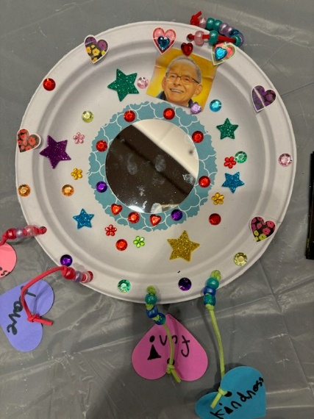Youth glue a paper circle in the center of their plate and then glue a round mirror on the paper. Then they attach string at the top to make a loop for hanging up their craft at home.
* Youth glue a picture of Sri Harold above the mirror, to remind them of the Mahanta holding up the mirror in the spiritual exercise.
* Youth choose stars with qualities of Soul that they want to focus on. They use string to attach beads and the stars to the circle.
* Youth can use markers and glitter and gem stickers to decorate their crafts and remind them of the qualities they have as Soul.
* Youth clean up their work spaces.

Break (Get a drink of water, go the restroom, chat, etc.)

Collaborative Song — Soul Dreaming (30 minutes)

Supplies

* Song lyrics
* Recorded music for “Soul Dreaming”
* Flip chart paper and markers
* The Activity Leader introduces the activity: *We’re going to create a song all about Soul. I’ll teach you the song first, and then you all   
  get to take turns adding qualities of Soul to the song.*
* The Activity Leader teaches youth the song.
* *Now it’s your turn to add qualities of Soul to the song. We’ll sing together and when we pause, raise your hand if you want to add a quality about Soul to the song.*
* The Activity Leader leads youth in singing the song, pausing for youth to take turns adding a quality of Soul to the song. A Group Leader writes each quality on flip chart paper.
* Go on until youth have added several qualities of Soul to the song, and then continue as time allows.
* Sing the song together with the qualities youth chose.

Clean Up, Sharing, and Feedback(15 minutes)

* Youth help clean up the room.
* Youth sit in a large group.
* Room Leader invites youth to share whatever they’d like to about their experience that afternoon.
* Room Leader asks for feedback on the activities they did that day, and ideas of what else the youth might want to do in future programs.

? Questions to ask can include but aren’t limited to:

1. What did you like doing today?
2. What could make it even better?
3. What kinds of activities would be fun?
4. What spiritual things would you like to learn about?